 

**MANUAL DOCUMENT VIEWER EMPLOYER**

1 Introduction 2

2 Login and choose password 2

3 Document viewer 4

4 Wage tax declarations (Loonaangiften) 5

5 Mutation forms 6

6 HR documents 6

# Introduction

Welcome at Salarisbalie. With this manual you will find your way to the Document viewer on [www.salarisbalie.nmbrs.nl](http://www.salarisbalie.nmbrs.nl). Should you have any questions, please send an e-mail to [info@salarisbalie.nl](mailto:info@salarisbalie.nl) with your name and telephone number and we will contact you as soon as possible.

With the Documentviewer you have 24/7 online access the salary output. If this is agreed with us, the employees have access to their payslips and annual statements. This saves paper, time and postage stamps.

# Login and choose password

For getting access to the Documentviewer you will receive and automatically generated e-mail message to activate your account.

Click on the link to active your account. **You must choose a password and pin code yourselves**. Enter this twice and click on Wachtwoord opslaan/Save password.

***Welcome at Salarisbalie.nl***

*Your employer has outsourced the payroll administration to Salarisbalie.Therefore, you receive a login account. This allows you to have access to your digital documents like payslips and annual statements. For questions about your payslip or e-mail address, the employer is the contact person.*

***Company name***

*Your user name is:*[*xxxxxx@xxxx.nl*](mailto:xxxxxx@xxxx.nl) *(your e--mail address)*

[*Click here to activate your Salarisbalie.nl-account.*](https://salarisbalie.nmbrs.nl/applications/Common/ExternalActions.aspx?view=4&activatekey=50b59dfd5f8046eb929722226d240f6d)

*We trust we have informed you sufficiently  
Kind regards,*

*Salarisbalie B.V.*

*Ronald van der Maarel*[*info@salarisbalie.nl*](mailto:info@salarisbalie.nl)

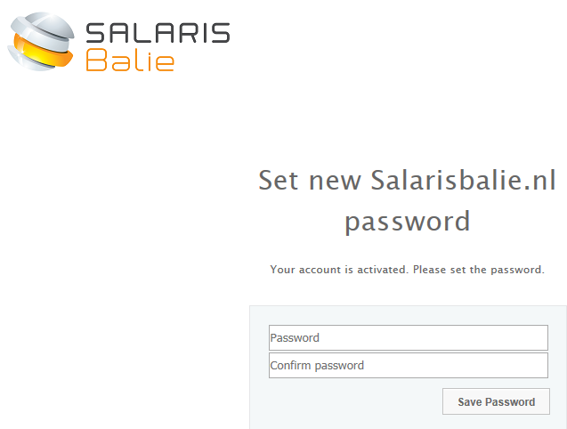

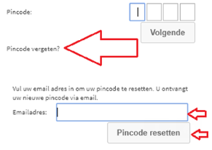

Then you can log in with the received username (e-mail address) and the password you have just chosen.

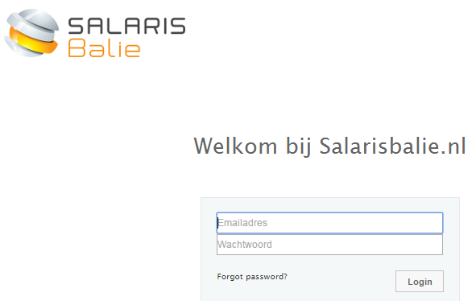

# Document viewer

After you entered the system, you will see an overview of the current year. Here is output available which can be downloaded en printed if you want (but you don’t want to print ☺).

With the button ‘More’ you will find the older years, if processed by Salarisbalie. Employees have access to their payslips and annual statements, unless we have agreed you prefer to print it out for them.

With the button ‘Actions’ you can change your password if you want.

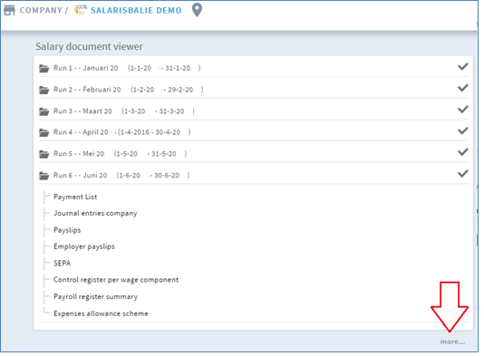

When you select SEPA, you can change the pay date and download the file to upload it in the banking system. No more failures. This works when the IBAN numbers from employer and employees are available in the system.

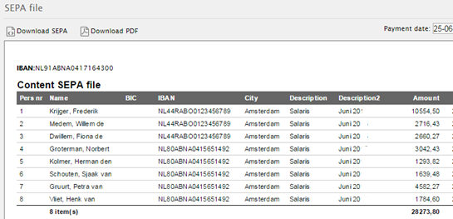

# Wage tax declarations (Loonaangiften)

We have sent the wage tax declarations to the Tax authorities. Here you will find the amount and payment reference which changes every month.

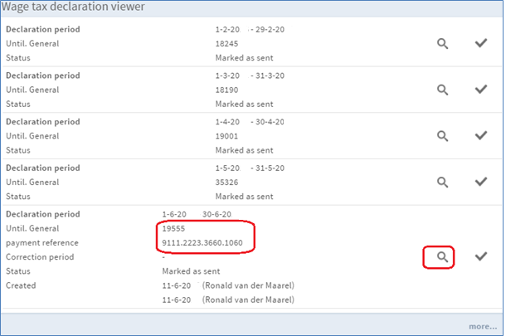

# Mutation forms requester

You can enter mutations online. But we also accept mutations by e-mail. Just what you prefer.

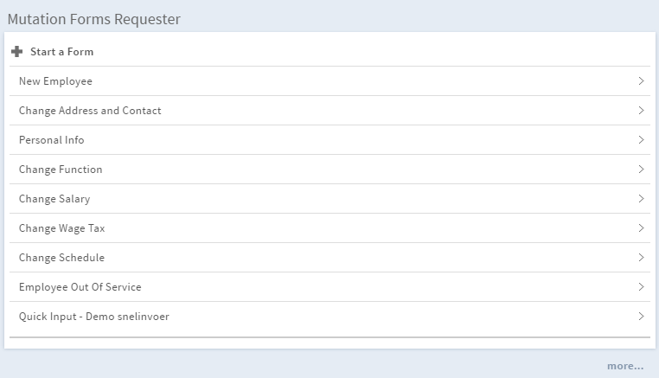

# HRM documents

Please take a look at the HR documents. It might be helpful for you.

When you use the optional Employee Self Service, you will find here leave- and sickness overviews.

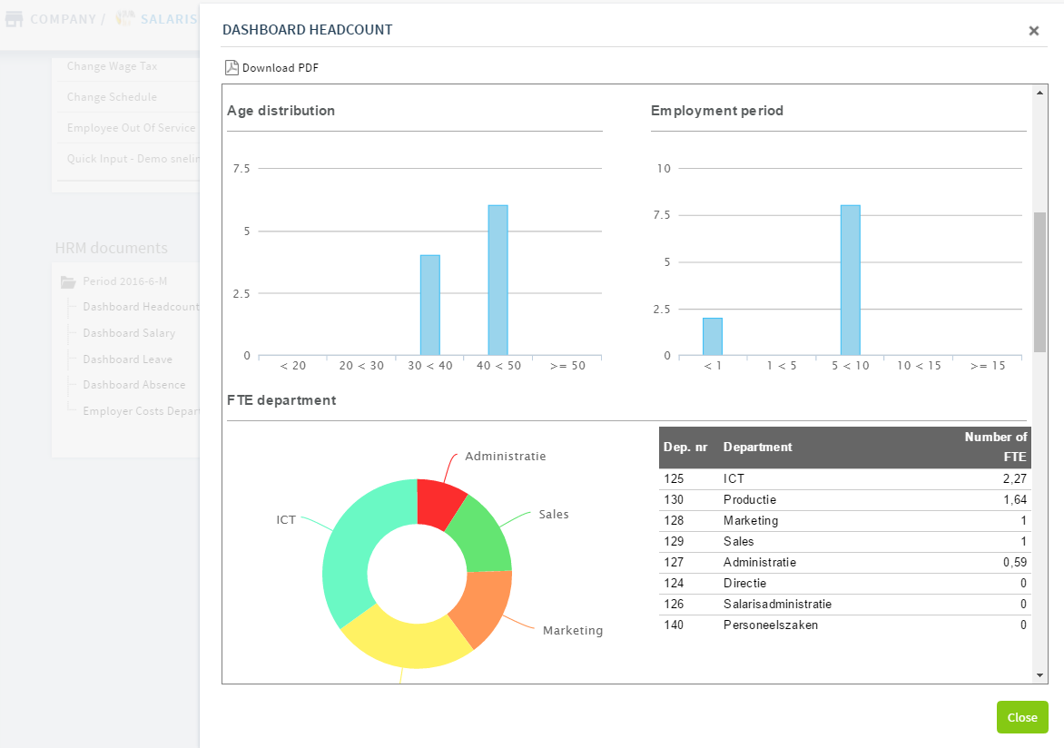

Should you have any questions, please do not hestitate to contact us.

Kind regards,

Ronald van der Maarel

+31 (0)88 888 3 555 / +31 (0)6 4513 4548

[www.salarisbalie.nl](http://www.salarisbalie.nl/)

Logo Salarisbalie DEF email handtekening

Schepenen 42 | 3961 LS Wijk bij Duurstede

The Netherlands